PROJECT NAME: - Fashion store

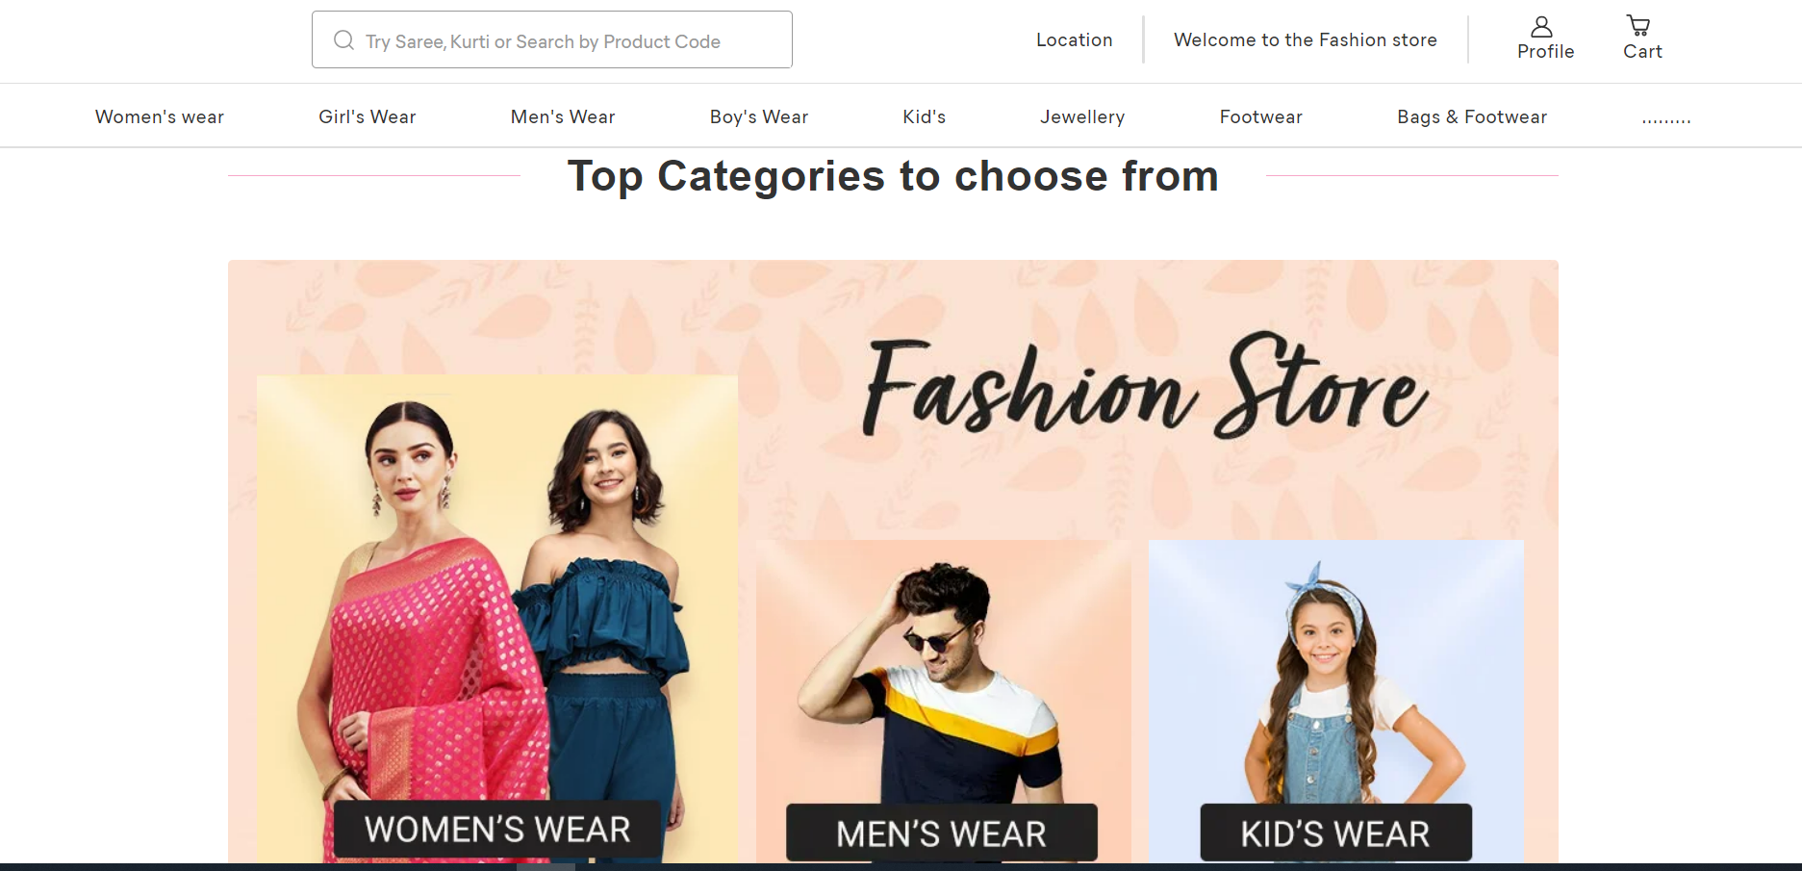

OVERVIEWS: -

It is an e-commerce website i.e. Fashion store for men’s, women’s Boy’s Girl’s and kids. There will be everything available on the same root like shoes, clothes, wallets, belts, sunglasses watch etc.

HOME PAGE: -

* + - **Navigation bar**
    - **Sub navigation bar**
    - **Aside as a filter**
    - **Main content**
    - **Footer**

NAVBAR: -

* + - **Logo**
    - **Location**
    - **Search bar**
    - **Add to card**
    - **Profile**

SUBNAVIGATION BAR: -

* + - **Kid’s wears**
    - **Boy’s wear**
    - **Girl’s wear**
    - **Men’s wear**
    - **Women’s wear**
    - **Jewelry**

FILTER: -

* **Relevance**

1. **New arrival**
2. **Prize**
3. **Rating**
4. **Discount**

* **Color**
* **Fabric Quality**
* **Prize**
* **Combo**
* **Jewelry type**

MAIN CONTENT: -

* **Some common fashion items**
* **Pagination bar**

FOOTER: -

* **Home**
* **Services**
* **Terms & condition**
* **About us**
* **Contact us**

1. **Gmail**
2. **WhatsApp**
3. **LinkedIn**
4. **GitHub**
5. **Twitter**
6. **Instagram**

PAYMENT METHOD: -

* **Phone-pe**
* **Google pays**
* **Credit card/Debit card**
* **QR code**
* **Paytm**
* **Net Banking**
* **EMI**